**3G Steganography tools. (S-Tools):**

1. Prepare the secret file that you want to hide (eg ME.txt)

1. Launch the **S-Tools**

1. Drag and drop the host file inside which you wants to hide secret file(img1.bmp)

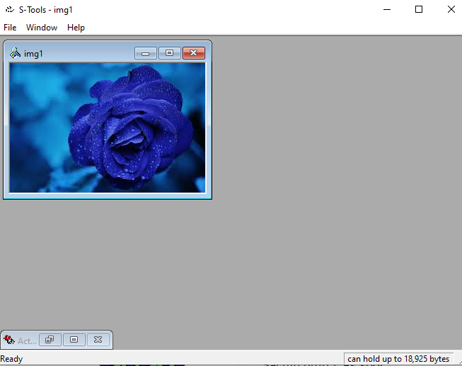

1. Now drag and drop the secret file on image file and alert by stool to enter password and choose encryption algorithm will come.

1. After entering password and algo, click ok. Tool will create identical copy hidden data.bmp

1. Right click and save it.

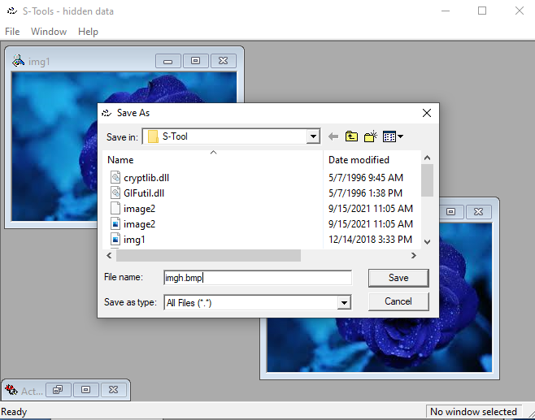

1. To reveal the hidden data open the file in S-Tool. Right click select reveal and put password and select algorithm.



